Birthday Party Package
Minimum of 15 people-ages 3+, 2 and under are free of charge and may
Not be included in the count of 15 people.

Included in this package:
The use of a covered private patio for 2 hours.
(May bring any decorations and food for the party and may
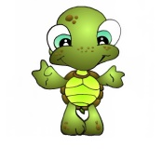
remain in the park beyond the 2 hours. Food brought into
the park may not be fed to the animals.)

Animal Encounter
(Private show for your party with animals of our choice.)

All the children with the party will receive a parakeet seed stick to feed the parakeets in the aviary.
Birthday child receives a coupon for a gift shop purchase.

Cost for package: $16.00 per person
$50.00 deposit required to reserve.

